1. Create one VPC, with 1 public subnet and 1 private subnet.

Create vpc by providing the name and CIDR range:



Create the internet gateway:



Attach vpc to internet gateway:

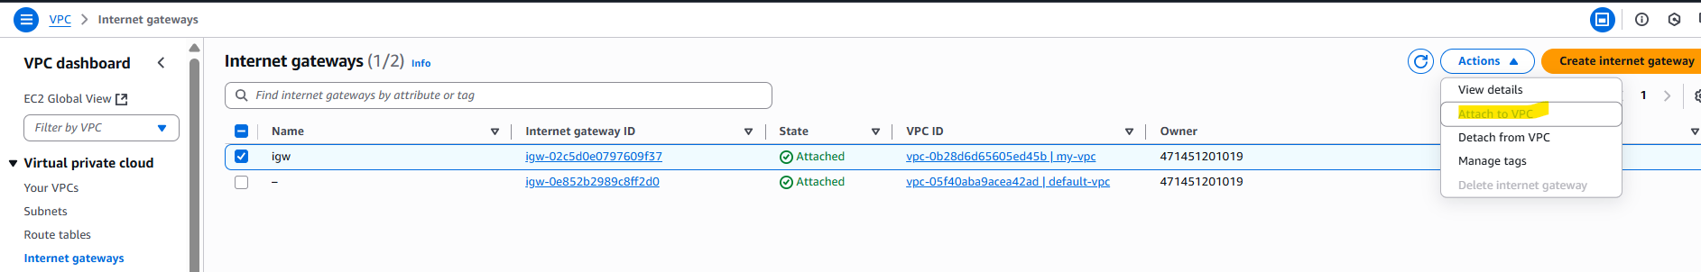

Create the subnet with CIDR range:

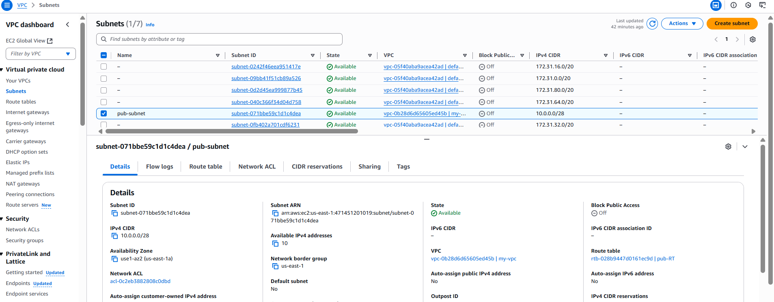

Add the internet gateway to the subnet->route table->routes

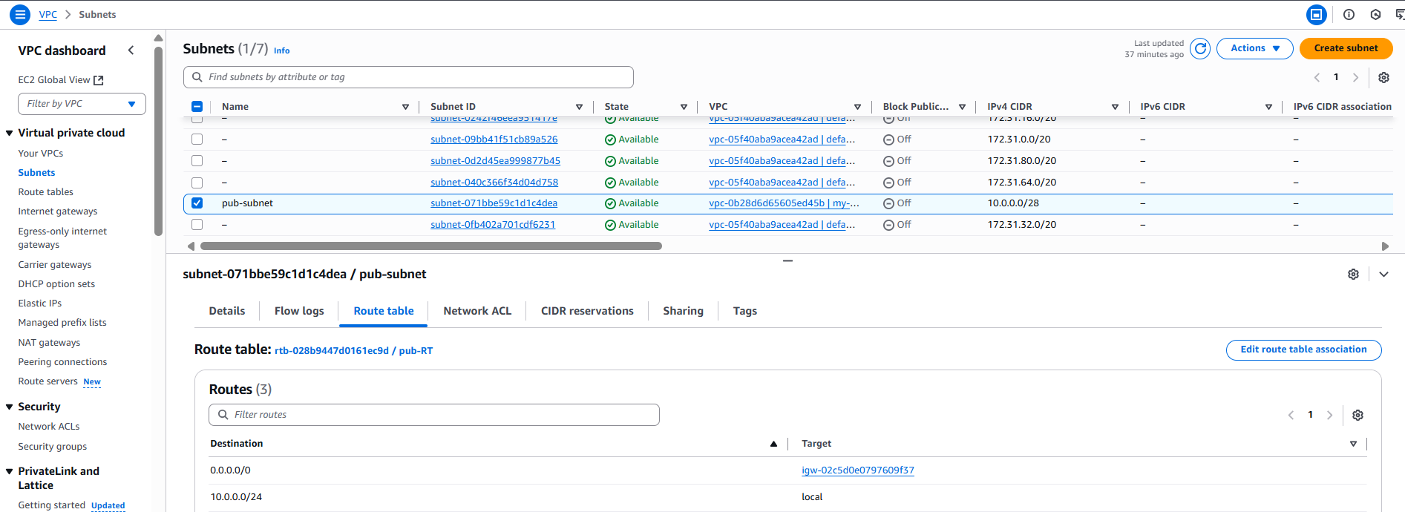

Creating Private Subnet:

In the Subnet Route Table ->Routes don’t add the Internet Gateway:

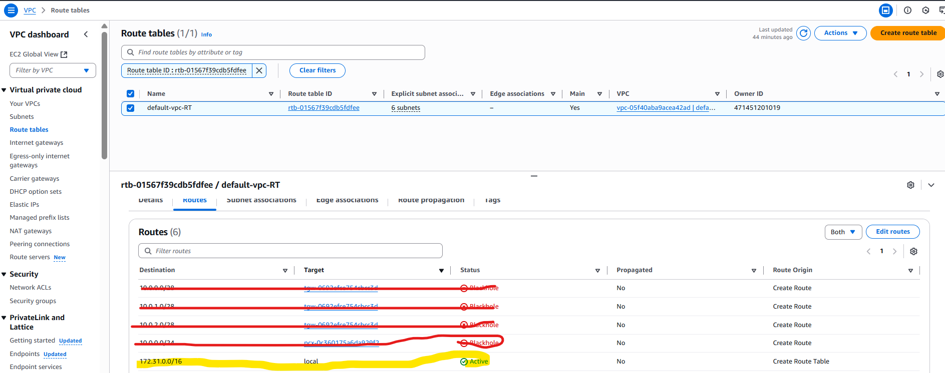

Then it will become the private subnet.

------------------------------done

1. Enable VPC peering for cross-region.

**Enabling VPC Peering for Cross Region in the Same Account:**

Create one vpc in Virginia Region with CIDR: 10.0.0.0/24



Create an Internet Gateway and attach to the above created VPC:

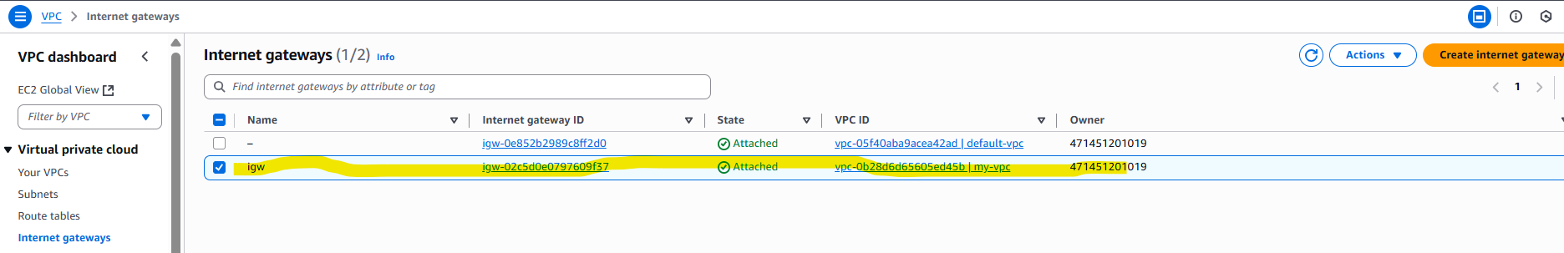

Create a subnet in the above vpc:

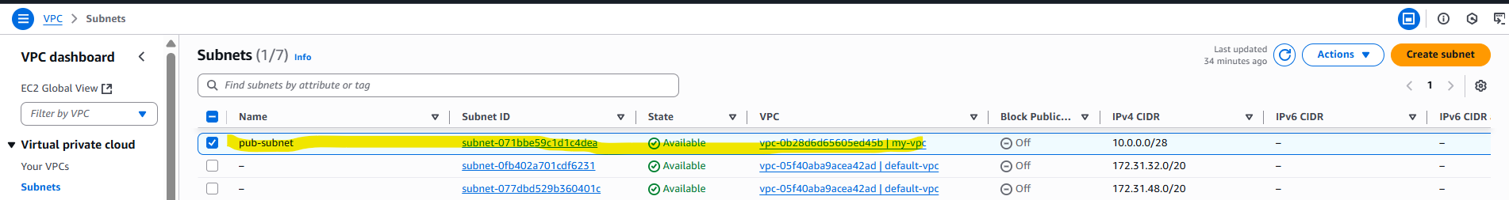

Add in the Routes ‘IGW’ in the route table and add the public subnet association:

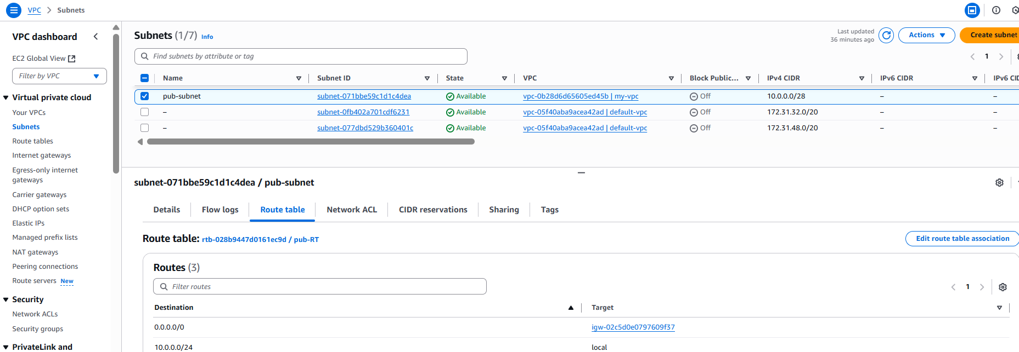

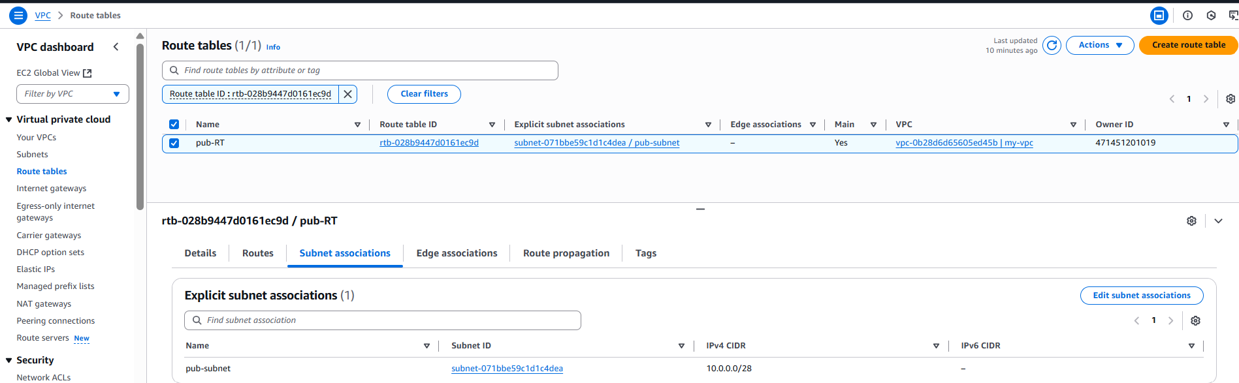

Launch the ec2 instance in the above created VPC:

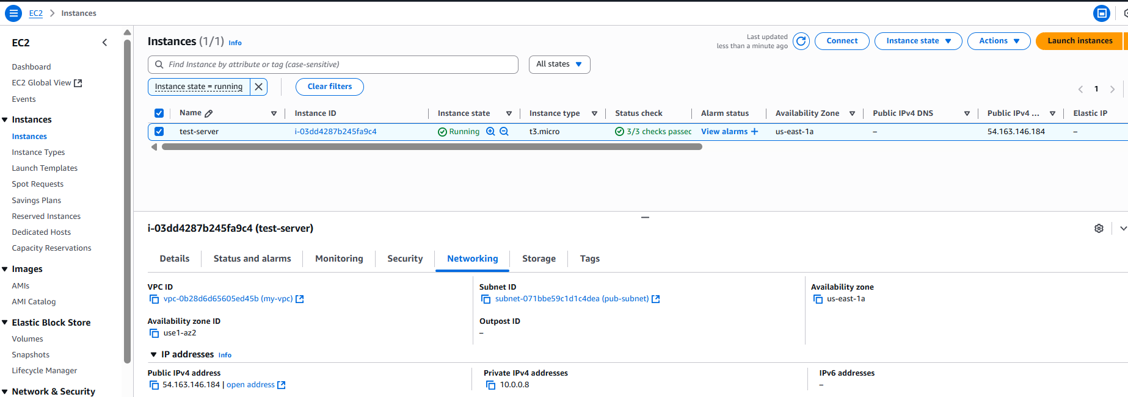

Try to access the ohio-Region ec2 private ip by login to N.Virginia ec2 then it will not get connec:

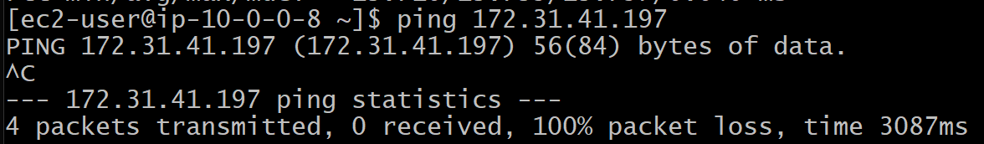

Launch an ec2 instance in the ohio Region with default vpc:

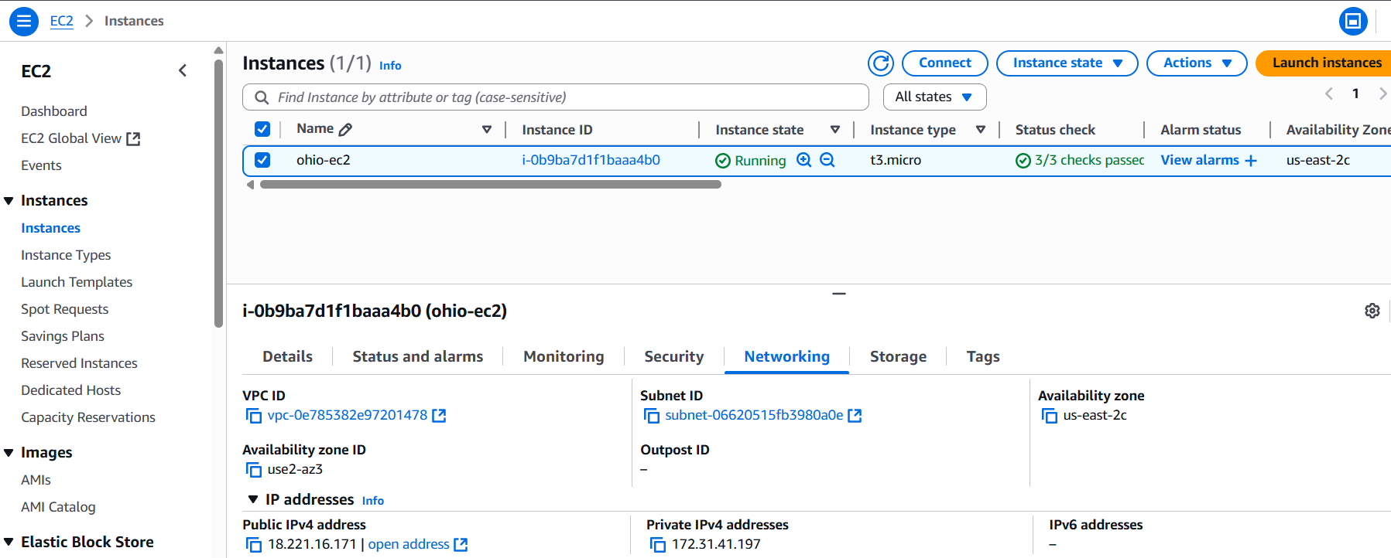

Create a vpc connection in ohio Region, give Requestor as ohio vpc id,and select the same Account and Different Region and give Region name:

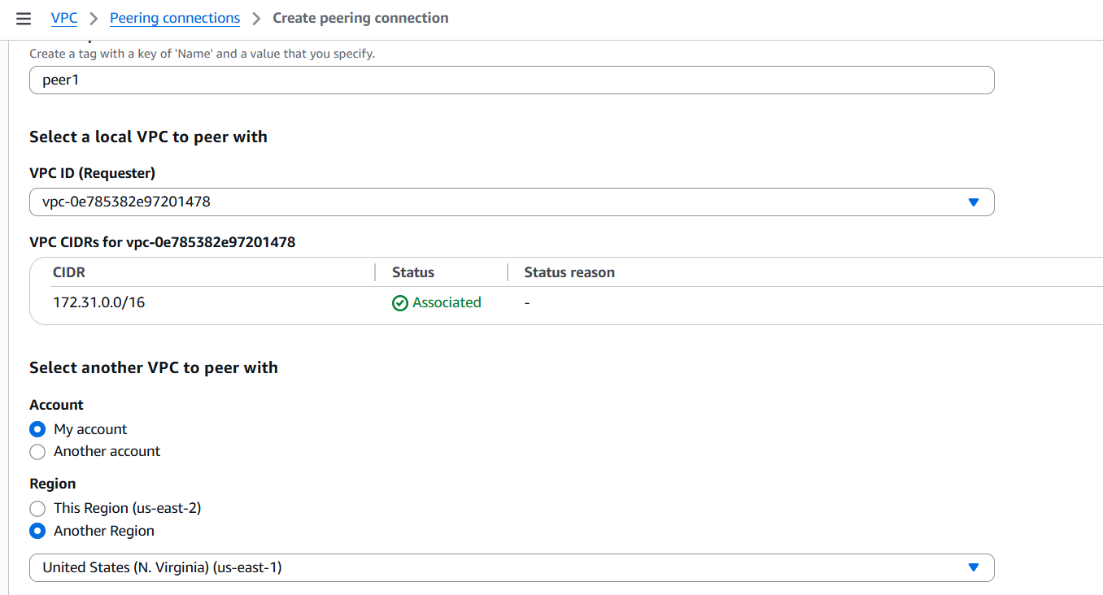

Give the Acceptor vpc id ( in this case N.Virginia vpc id which is Acceptor) and create peering connection:

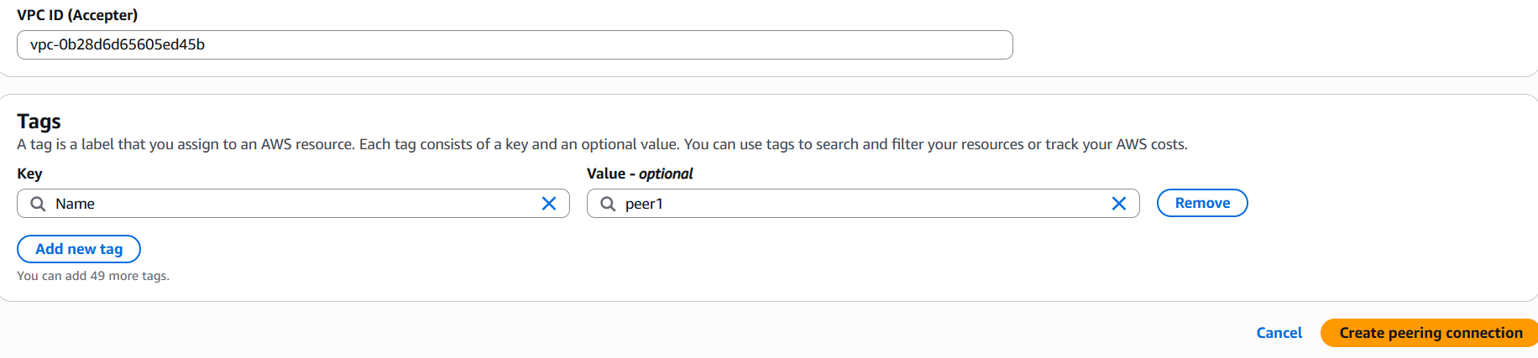

Add the ohio vpc CIDR to peering connection in the route table of N.Virginia vpc subnet:

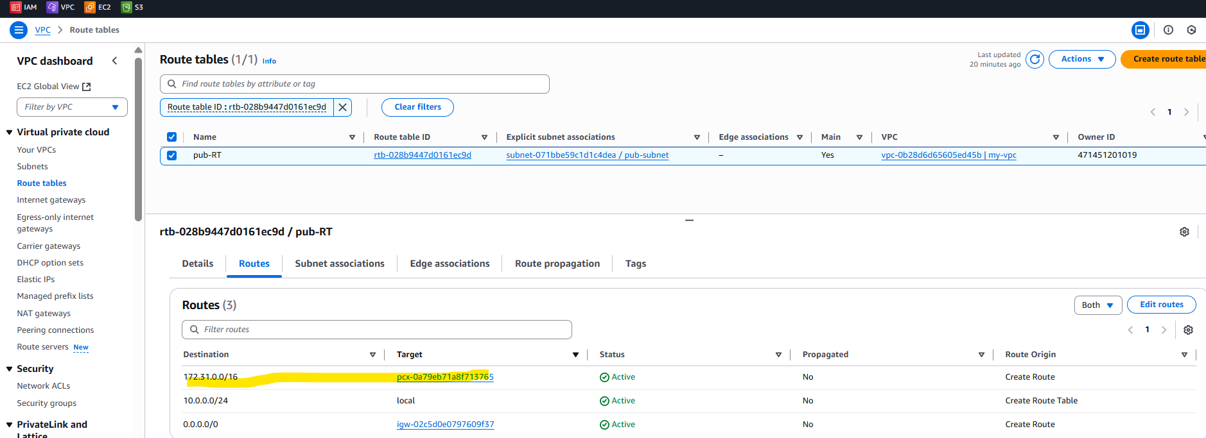

And Add the N.Virginia vpc CIDR to peering connection in the route table of ohio vpc subnet:

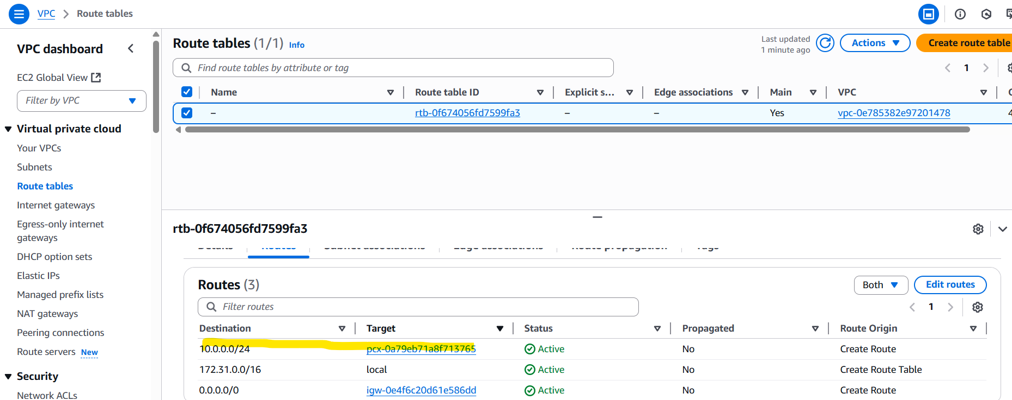

Now try to access the private ip of ohio ec2 from N.virginia ec2 then we are able to connect now:

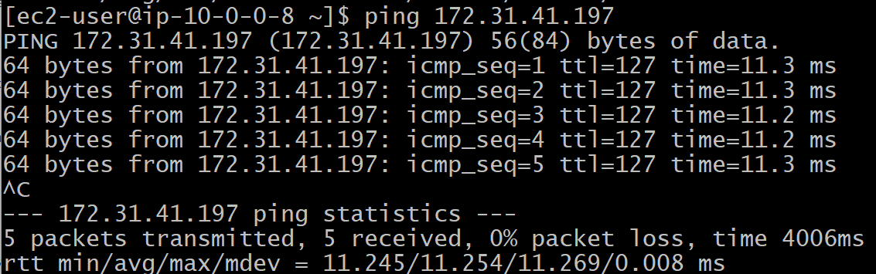

And try to access the private ip of N.Virginia ec2 from ohio ec2 then we are able to connect now:

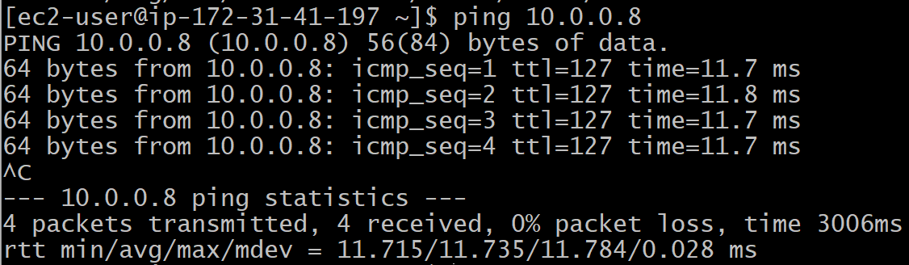

----------done------

1. Enable VPC peering for cross-account (you can collaborate with your friend to do this task).

Create peering connection in Account A:

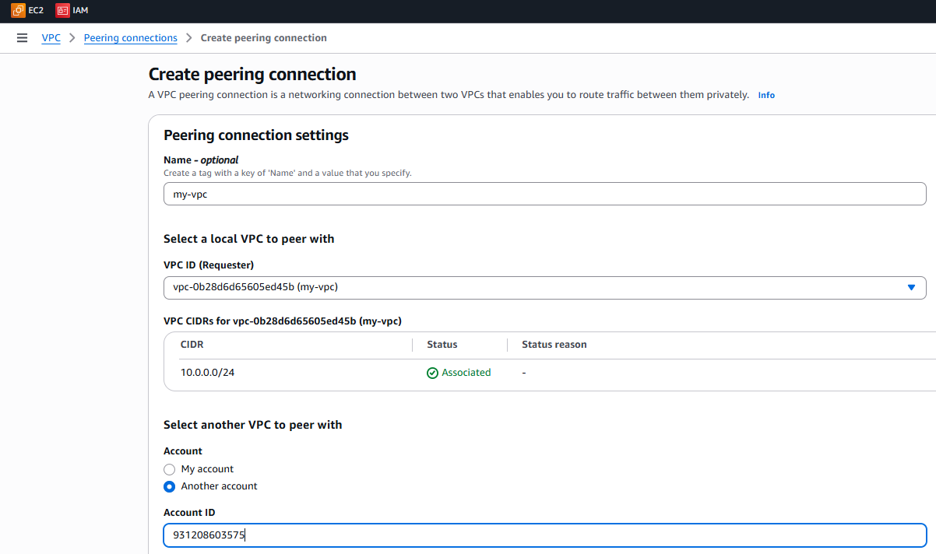

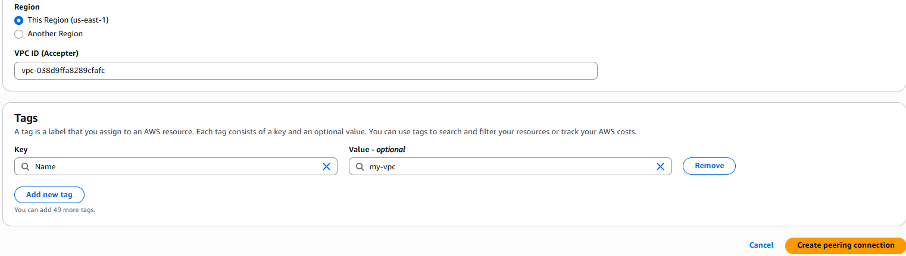

Then goto the Account-B and Accept the Request, then it will become active:

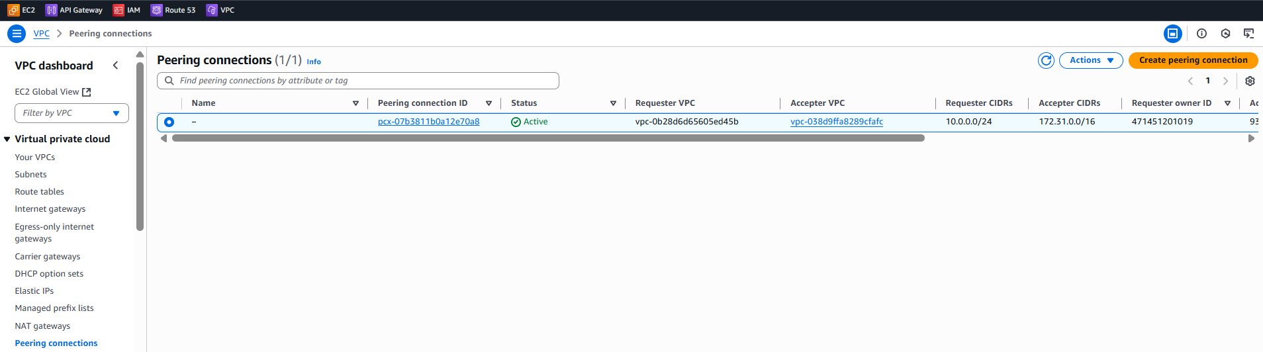

Then in the route table of Account-A add the CIDR of Account-B vpc:

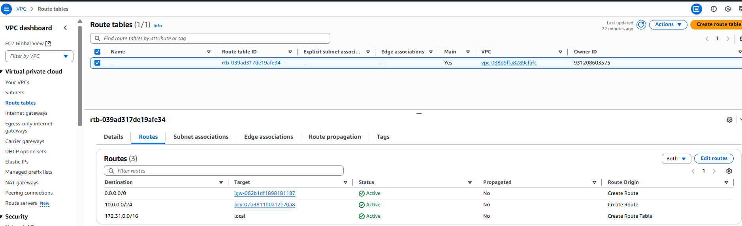

And in the route table of Account-B add the CIDR of Account-A vpc:

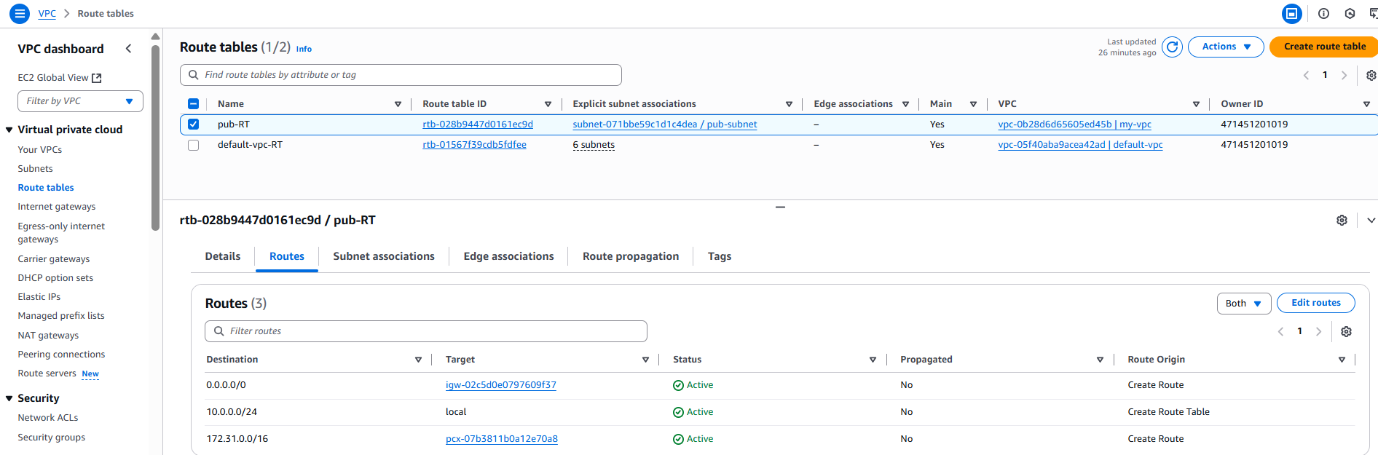

Then we can able to ping to other account ec2 private instance:

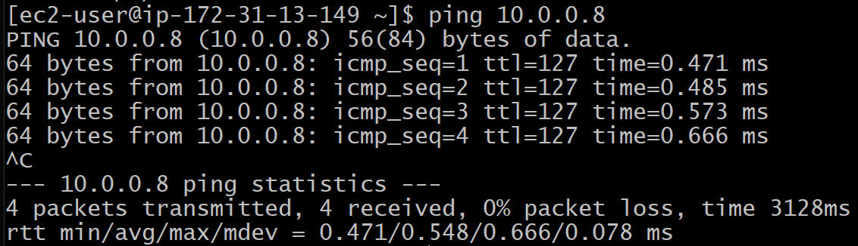

Same in the other account:

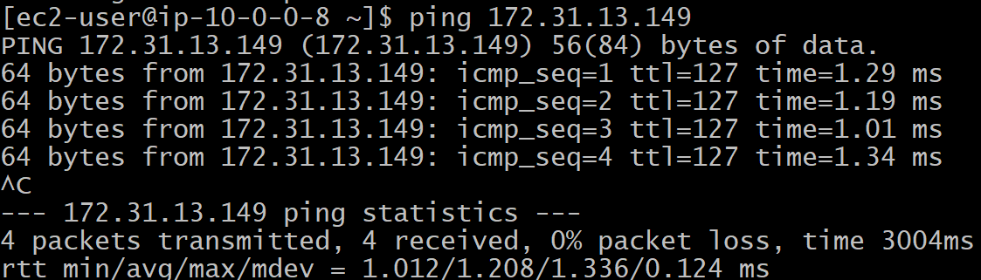

-----------------done---------

1. Set up a VPC Transit Gateway.

**Create 4 vpc , 1 will be default vpc, and you create another 3 vpc with name vpc-1,vpc-2,vpc-3.**

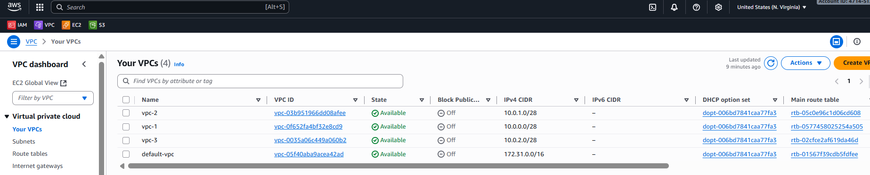

**Create Transit Gateway with default configuration:**

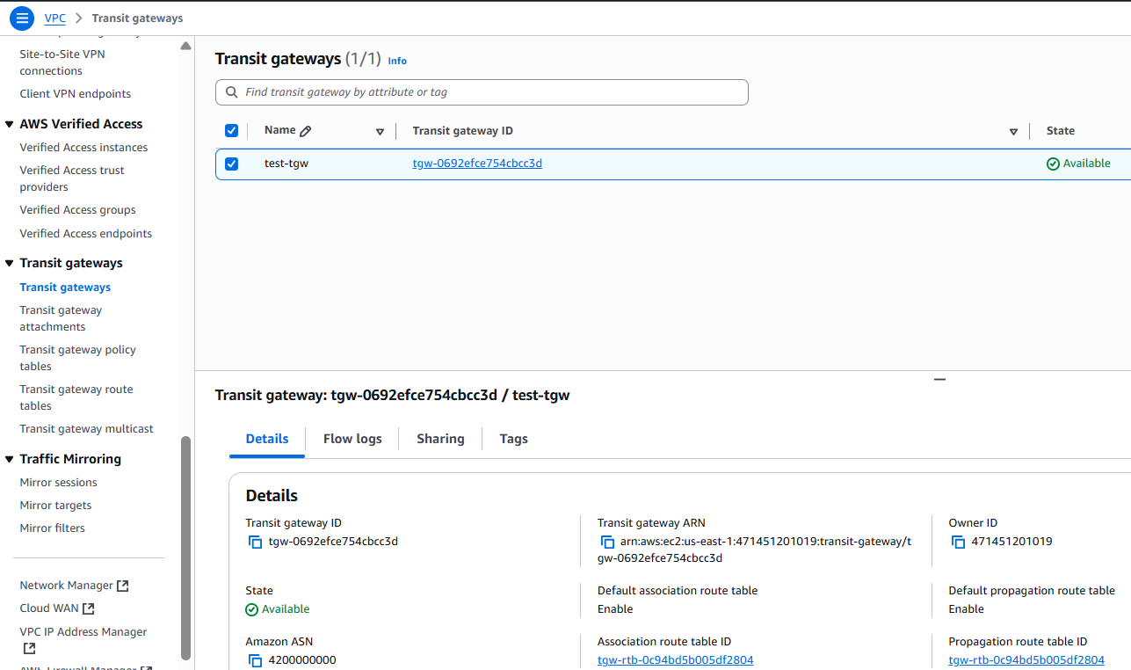

**Now goto Transit Gateway attachments and create 4 attachments for 4 vpc.**

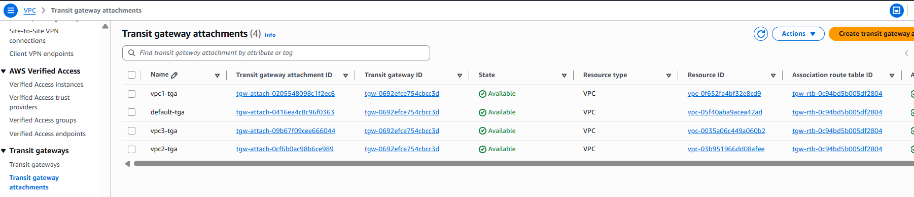

**After creating TGW attachment it will create by default one TGW Routing Table**

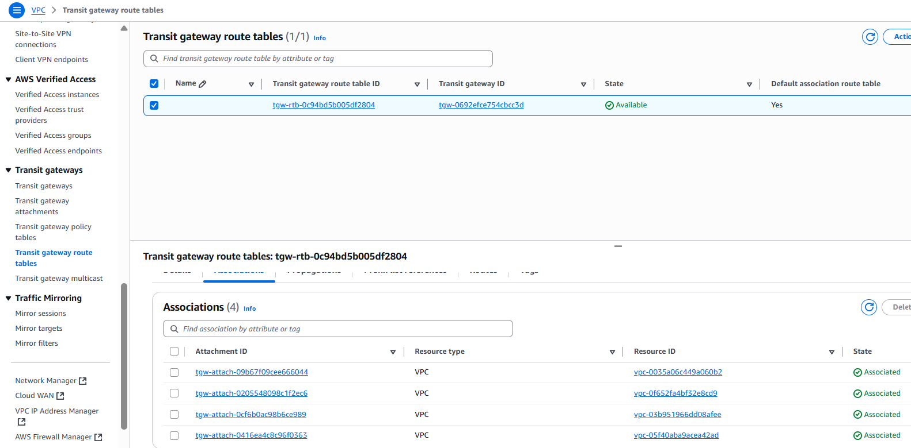

**Next, Launch 4 ec2 instances in 4 vpc means each vpc 1 ec2 instance:**

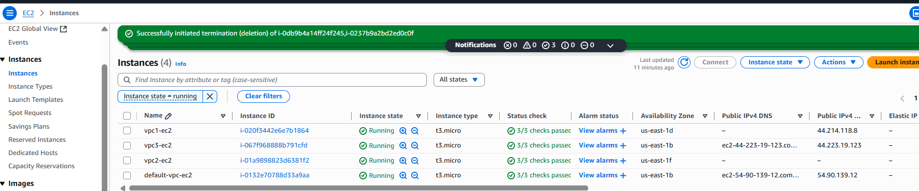

**Next, login to default vpc-ec2 and now I want to communicate from this vpc ec2 to the ec2 which is in vpc1 i.e., vpc1-ec2 :**

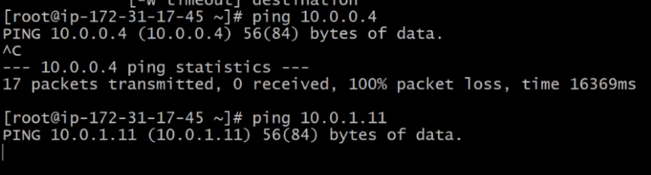

**But we are not able to access because we have not mentioned in the vpcs where the traffic needs to be re-directed.**

**Update your all vpc Routing Tables with this routing policies:**

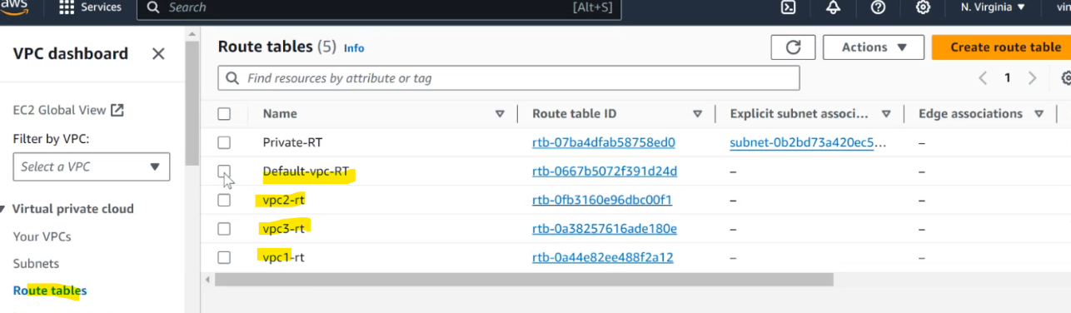

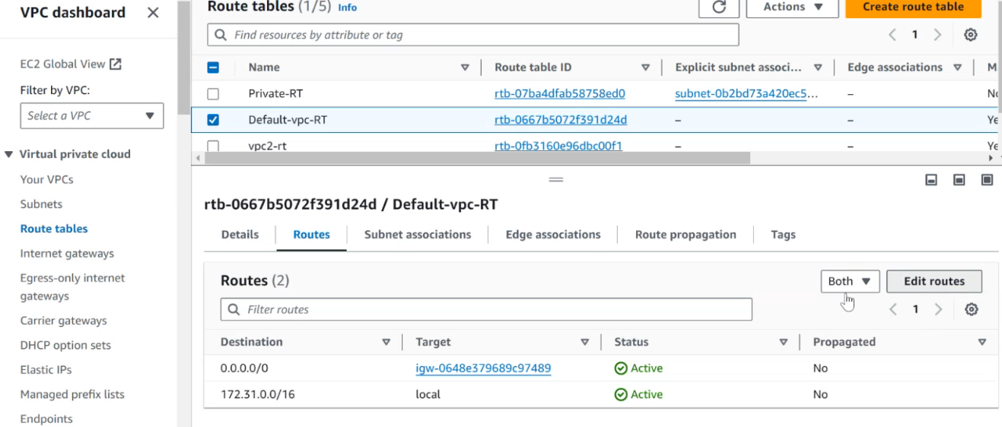

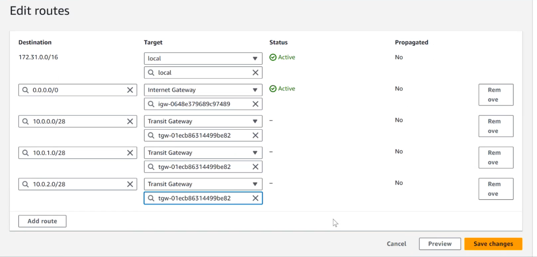

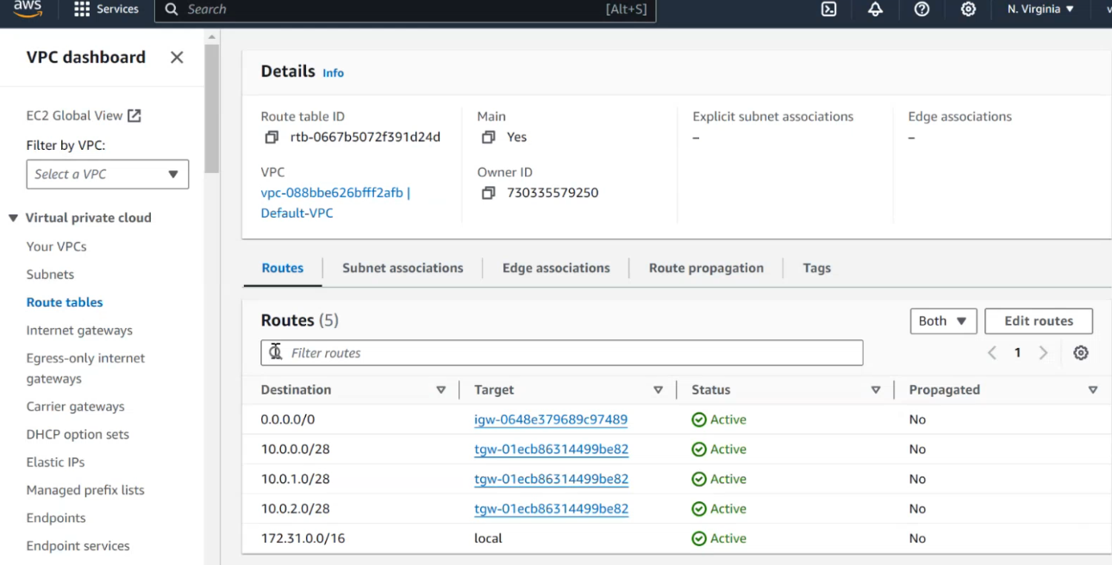

**Do attach the same in other vpc RT:**

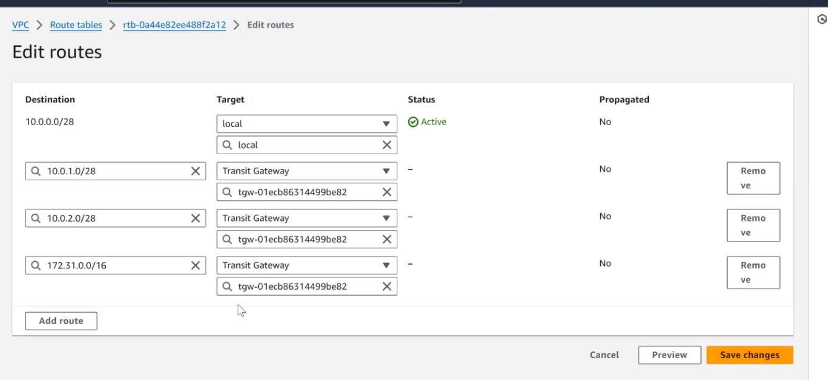

**Create 3 Internet Gateway and Attach to each vpc means every vpc.**

**To each Route Table add the igw.**

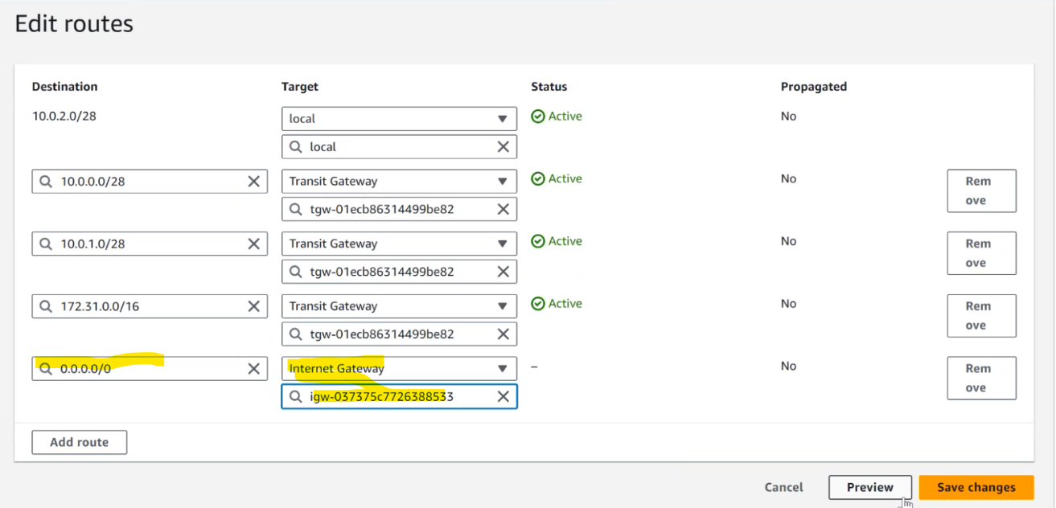

**And then open the port from security group, and we can see we are able to connect:**

**Now, we can connect to any ec2 instance from any default vpc:**

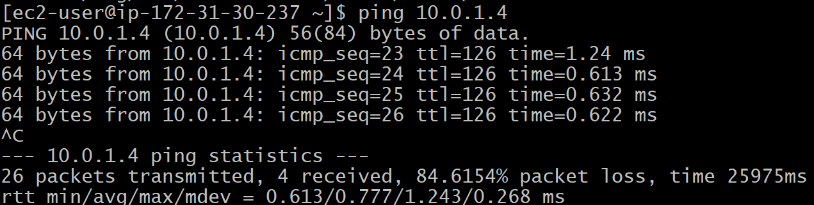

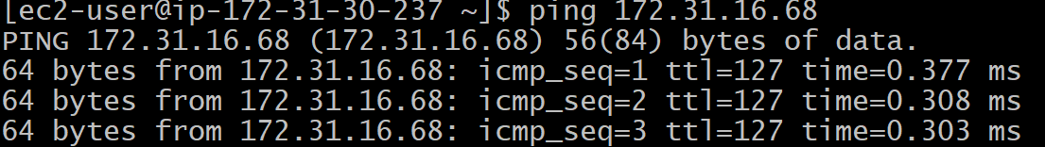

----------------------------------------

1. Set up a VPC Endpoint.
   1. **Create 1 vpc**

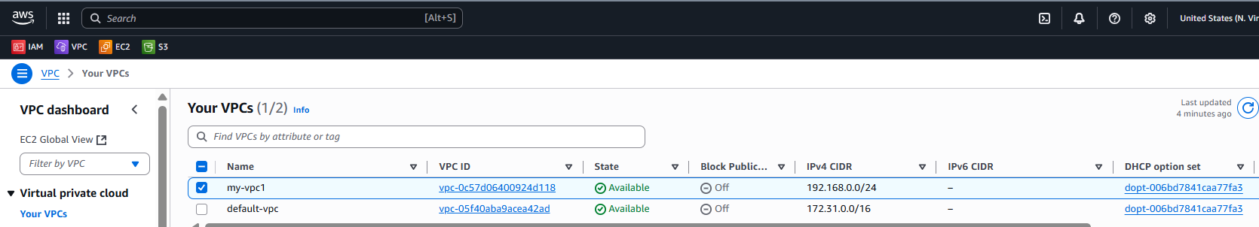

* 1. **Creat 2 subnets one public, and one private**

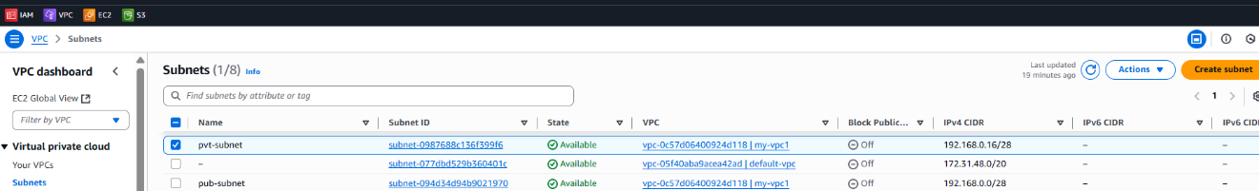

**Add internet gateway in the Routes of public Route Table:**

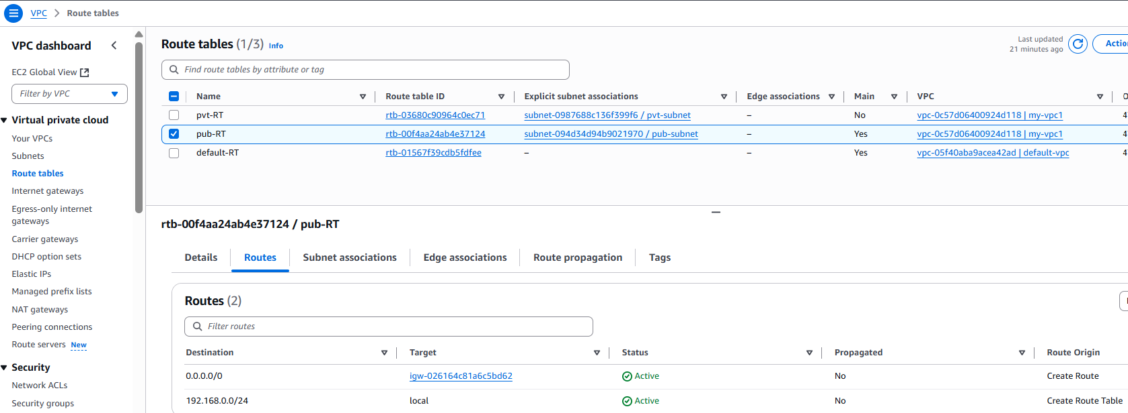

**Associate public Route Table with public Subnet:**

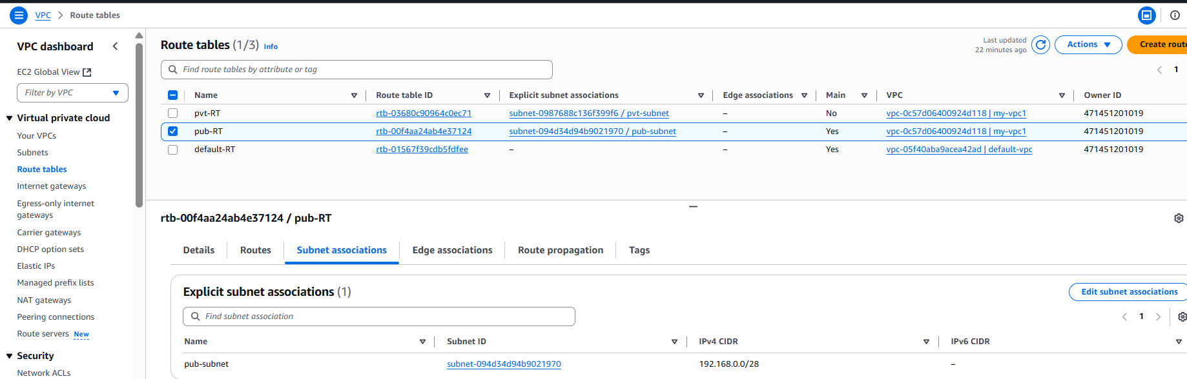

**Create the Private subnet and Route table contains only local routes:**

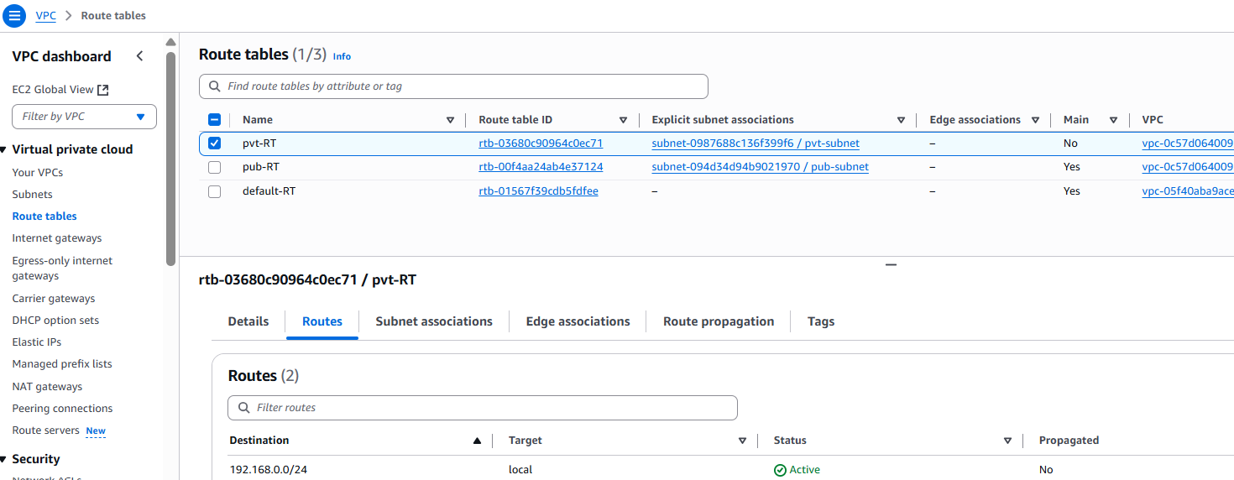

**Associate Private Route Table with private subnet:**

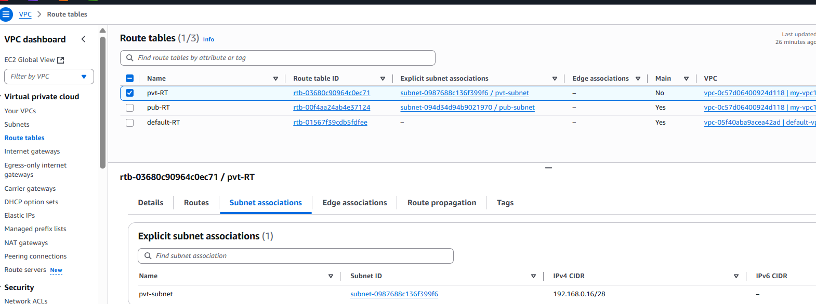

* 1. **Launch ec2 instance within the public subnet**

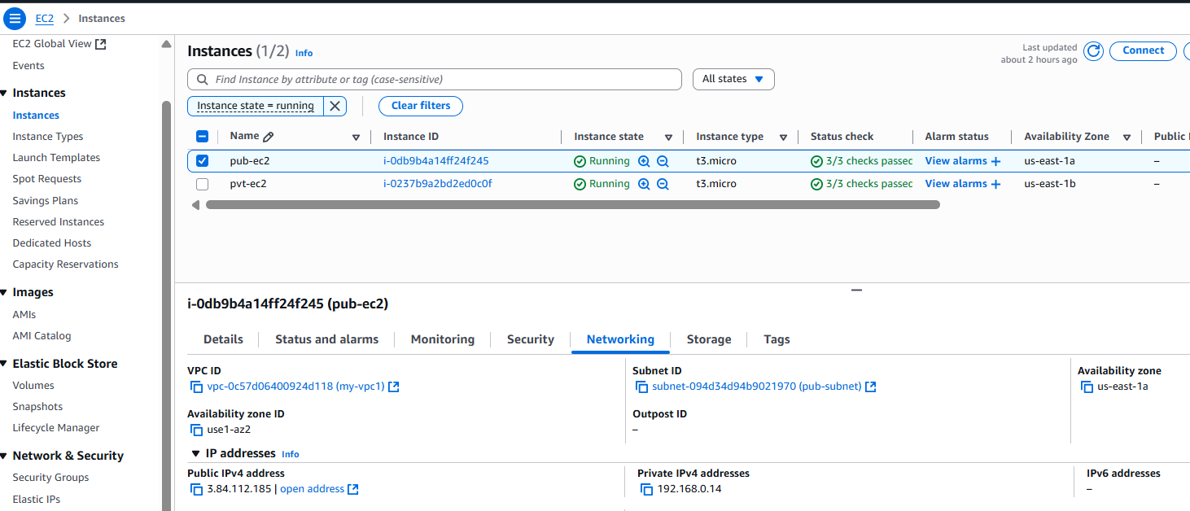

* 1. **Launch one ec2 instance in private subnet:**

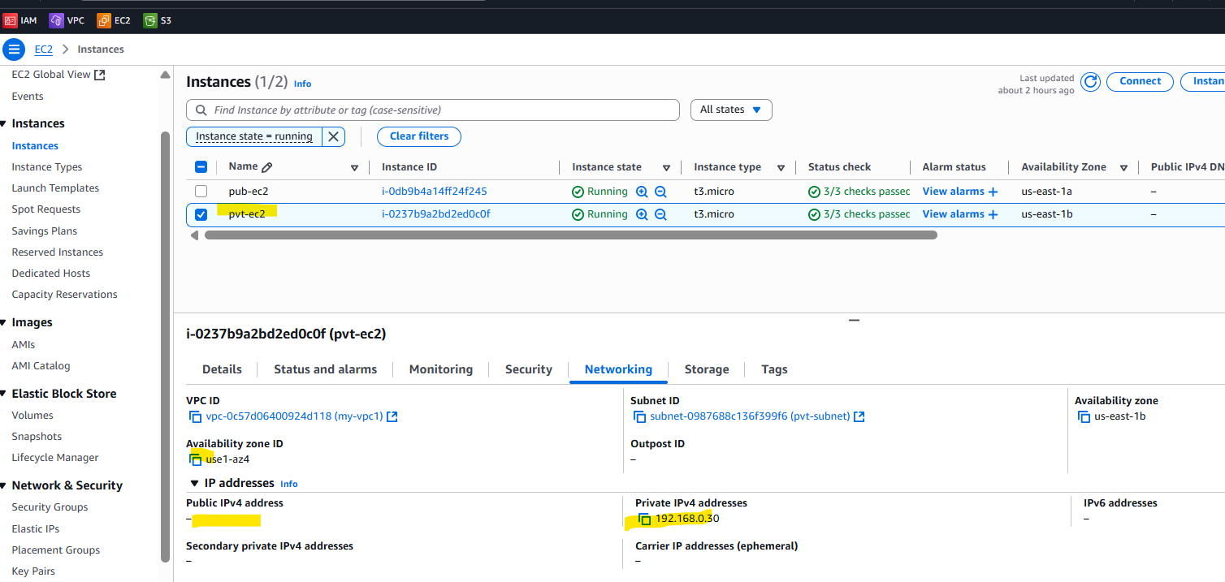

* 1. **Create one s3 bucket.**

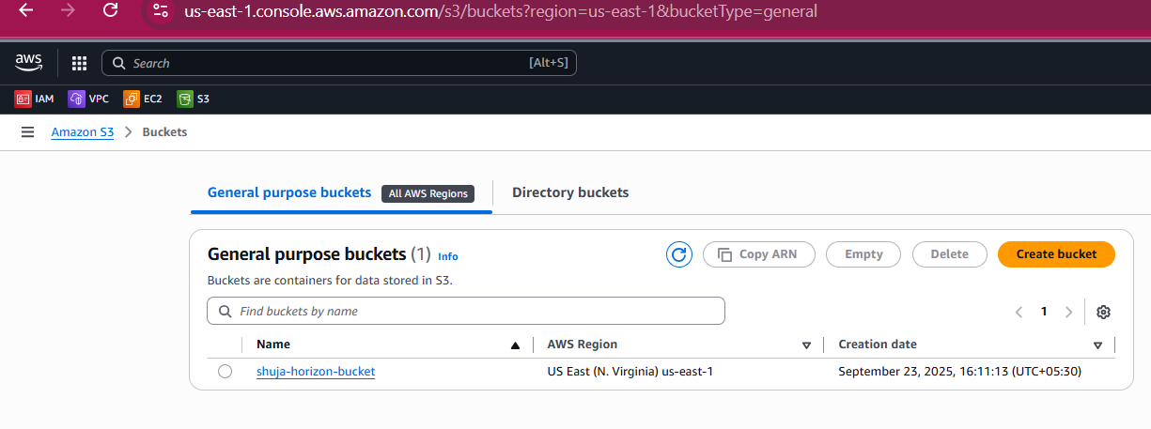

* 1. **Configure the aws credentials using ‘aws configure’ and we can see in the hidden directory .aws:**

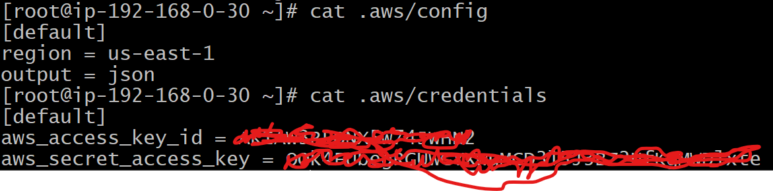

* 1. **and then try to access the s3 from the public subnet ec2(login to ec2)by using aws cli command:**



**Next, I want to get those details from the ec2 instance which is hosted in private subnet, so**

1. **login to private ec2 instance by jump server/Bastion Server, and setup Credentials and try to access the aws s3:**

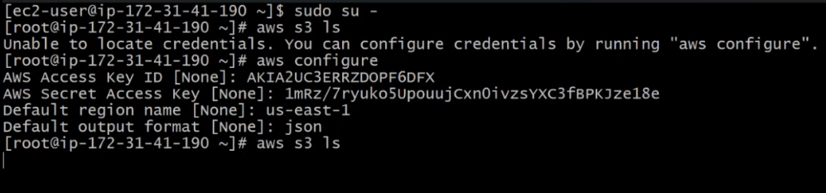

**Create one end-point :**

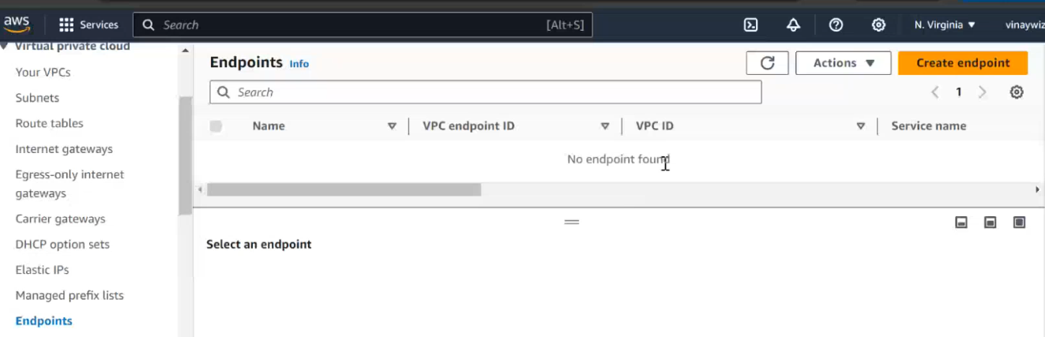

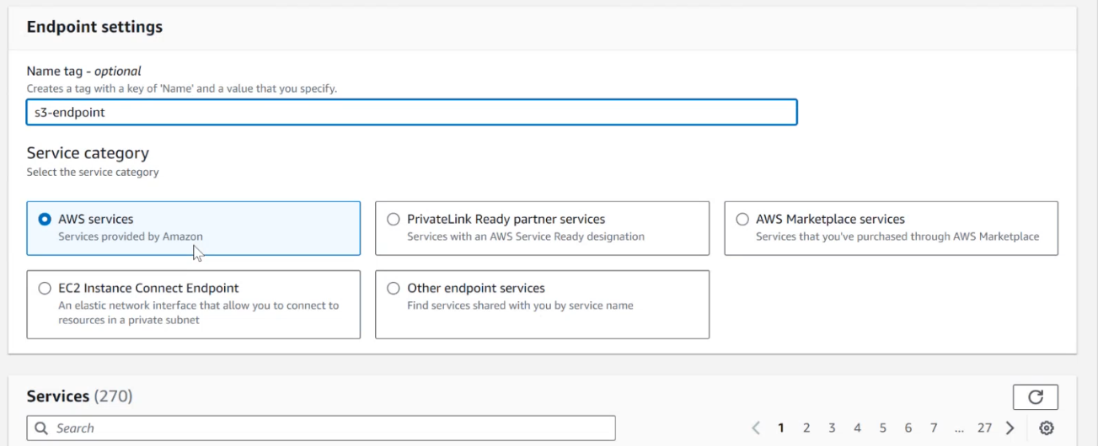

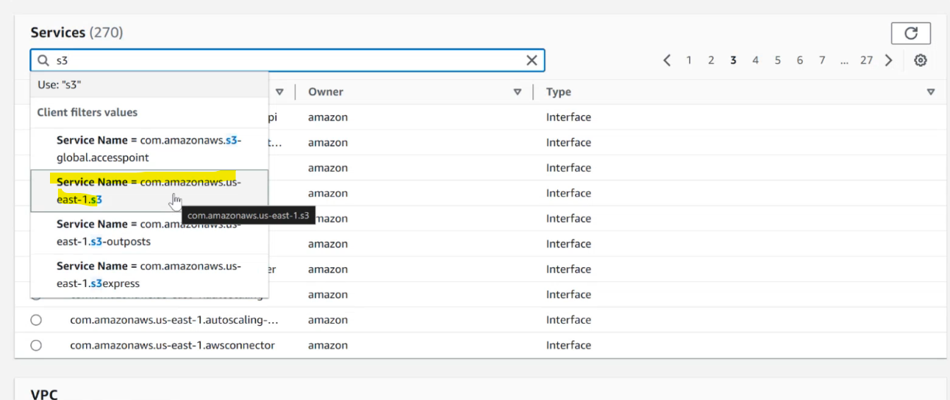

* **Gateway: will directly attach to our Routing table and it will take care of the request.**

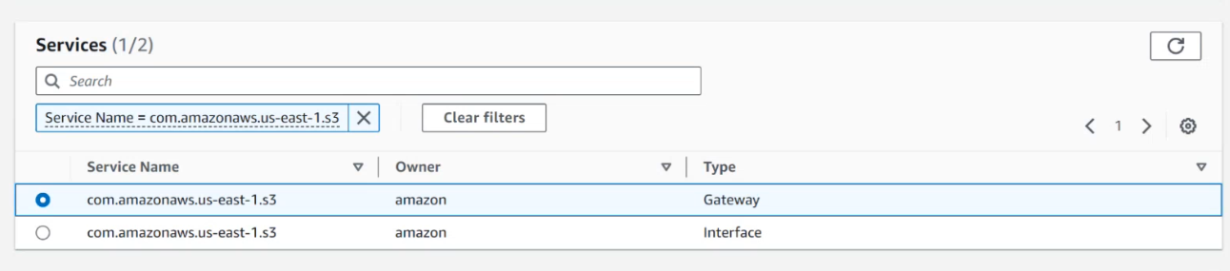

**Then assign the endpoint with which vpc:**

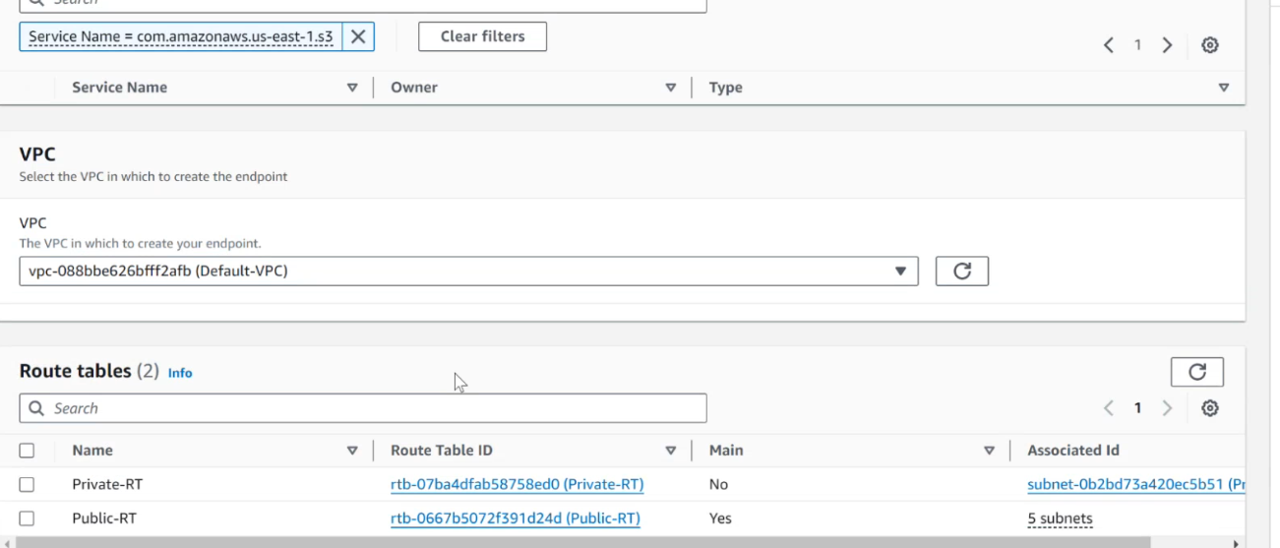

**And then which Routing Table you want to use:**

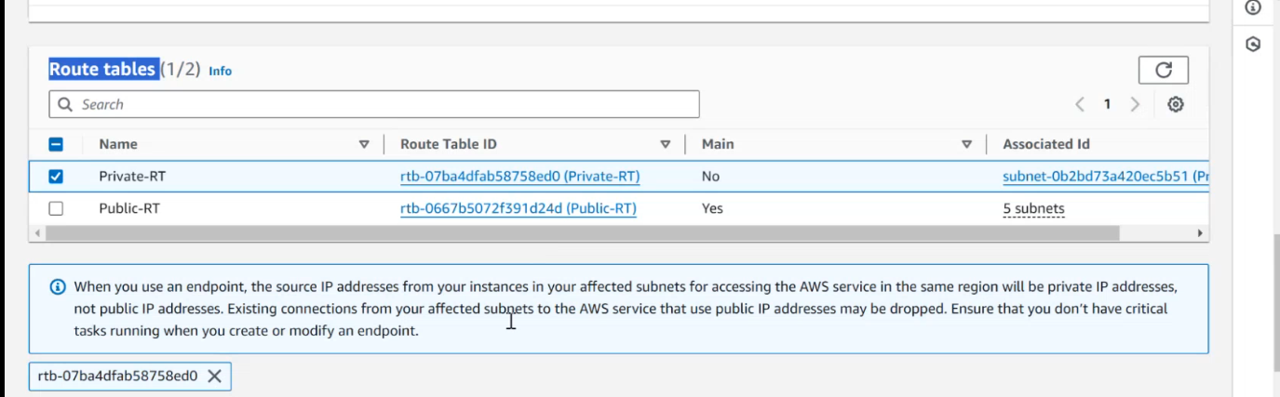

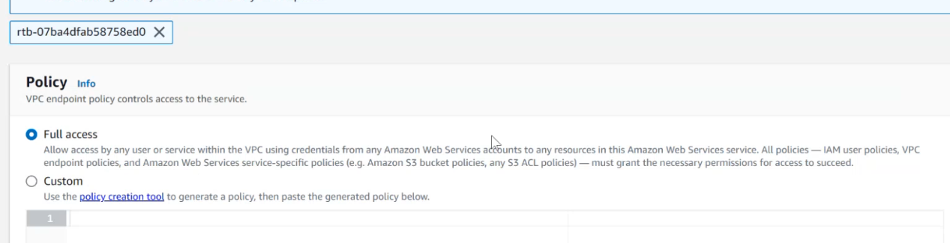

**And create endpoint:**

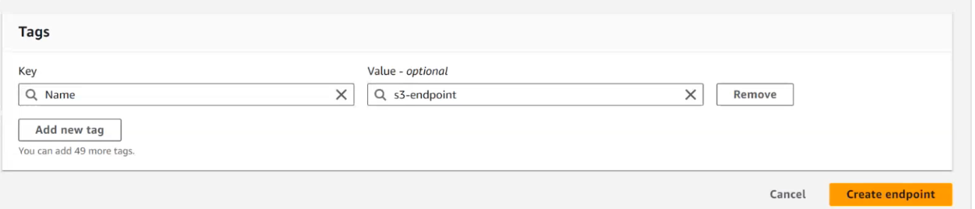

**And once the ‘endpoint’ has been created we can see in the Routing Table of private subnet that one Destination has been added:**

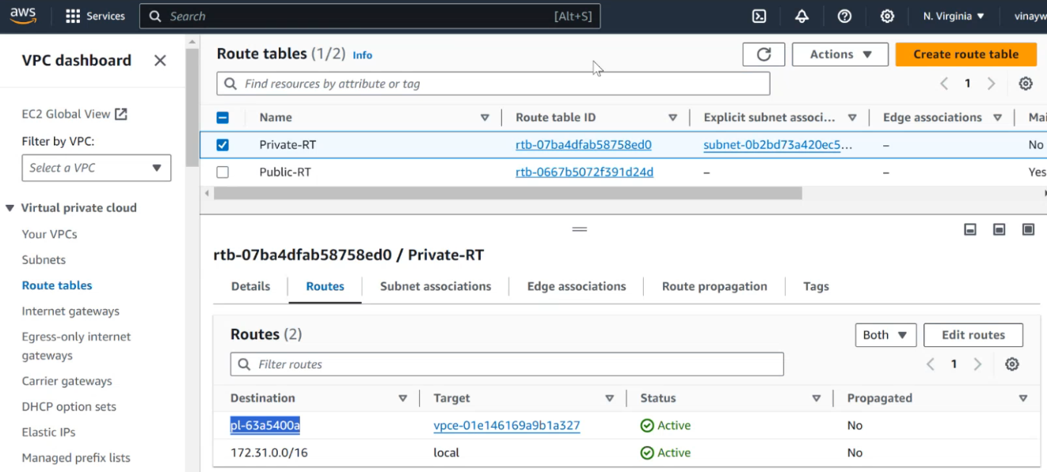

**Means we have attached our RT of our private subnet to the endpoint and this endpoint is mapped with s3. And now if you see ‘aws s3 ls’ from private subnet ec2 we are able to get the details:**



**-----------------completed-----------------**